Joe Clancy

11/16/2024

CS499

4-2 Milestone: Algorithms and Data Structures Narrative

The Algorithms and Data Structures artifact I am demonstrating is a C++ program that implements a binary search tree (BST) data structure, ingests a university course catalog from a CSV file, loads the course information into the BST, and allows users to view the entire catalog or single courses. I originally created this artifact for CS300: Data Structures and Algorithms in August 2024. The following example demonstrates the program’s functionality before any enhancements have been implemented.

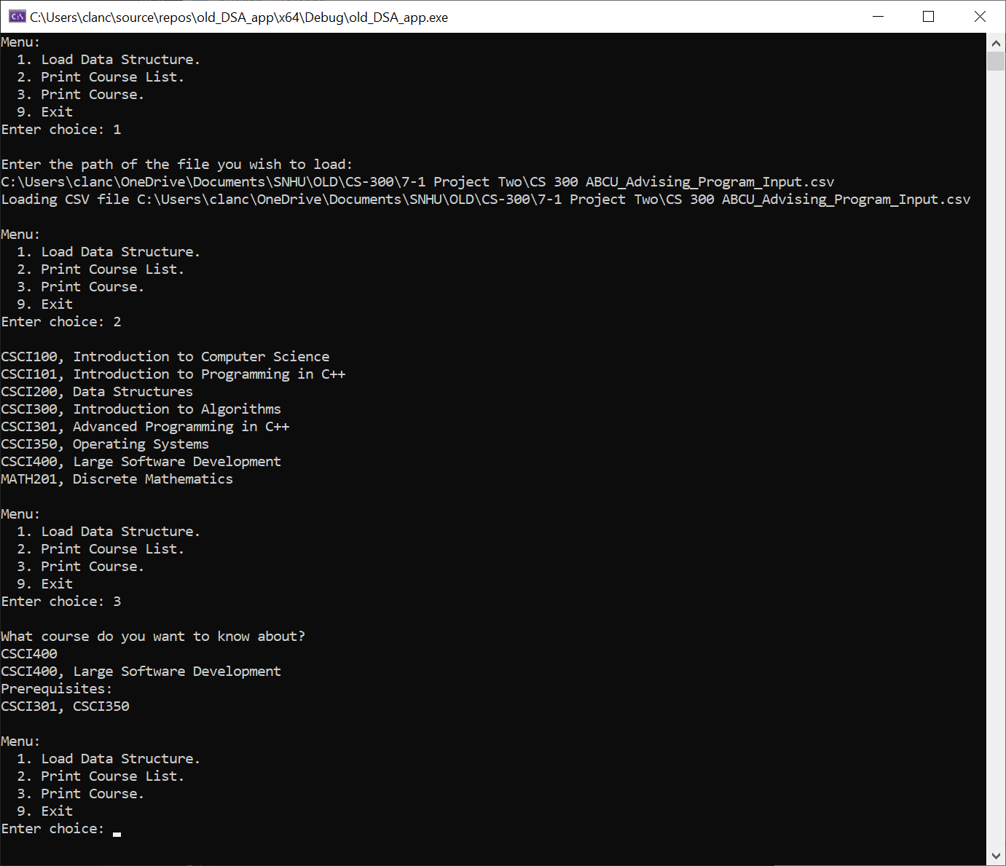

This artifact is an excellent example of my skills with algorithms and data structures for several reasons. A CSV is an extremely common format for storing and moving data, especially in smaller enterprises or environments where users have limited access to technical expertise. Parsing a data structure of this type is a common task and presents an opportunity to validate the data it contains. Then loading that data into a more efficient data structure like a BST improves efficiency for future operations. These tasks highlight the value my skills, and computer science in general, can provide to immediately benefit end-users with data-intensive use cases. This aligns well with the course outcomes:

Design and evaluate computing solutions that solve a given problem using algorithmic principles and computer science practices and standards appropriate to its solution, while managing the trade-offs involved in design choices

Demonstrate an ability to use well-founded and innovative techniques, skills, and tools in computing practices for the purpose of implementing computer solutions that deliver value and accomplish industry- specific goals

In its original state, however, this artifact does not support an end-to-end workflow for course catalog operations. This is undesirable because it would require users to directly modify the dataset, limiting the value of data validation, or perform updates in separate software, complicating the workflow, in order to take advantage of the artifact. To remedy this limitation, I chose to enhance this artifact with the ability to add, edit, and delete course information and to export the entire dataset to the same or a new CSV. Options to support each of these new functions were added, as well as sub-menus for several of them. The BST implementation also needed to be expanded to accommodate this functionality.

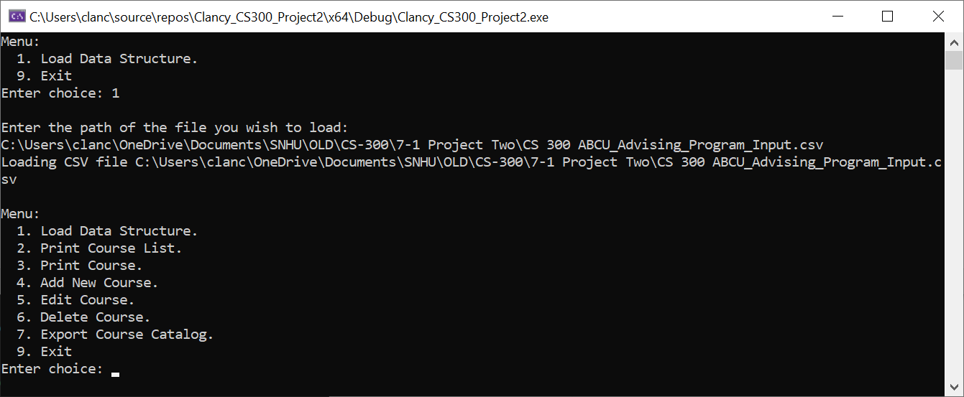

Additional error checking was added to ensure that the artifact gracefully handles erroneous user inputs, such as invalid files or file paths. Menu options also do not become available until the user has loaded a dataset, clarifying the correct workflow.

The ability to add and edit courses is supported by its own sub-menus. Validation prevents any courses from being added as pre-requisites that do not already exist in the course catalog, ensuring the integrity of the dataset.

A confirmation prompt protects users from deleting courses unintentionally. Courses that are pre-requisites for other courses in the catalog cannot be deleted unless the dependent courses are deleted first, preventing phantom course references.

The export function will default to the same CSV loaded at the beginning of the workflow, but the option to export to a separate file is also available.

These enhancements additionally help to support the course outcomes:

Design and evaluate computing solutions that solve a given problem using algorithmic principles and computer science practices and standards appropriate to its solution, while managing the trade-offs involved in design choices

Demonstrate an ability to use well-founded and innovative techniques, skills, and tools in computing practices for the purpose of implementing computer solutions that deliver value and accomplish industry- specific goals

Making the end-to-end workflow of accessing, modifying, and exporting a course catalog available to users with limited technical expertise in a single application also supports the course outcome:

Employ strategies for building collaborative environments that enable diverse audiences to support organizational decision making in the field of computer science

These outcomes align with the outcomes I planned to cover with this artifact, so my outcome coverage plan will not require modification at this time.

The biggest challenge I faced as I enhanced this artifact was expanding the functionality of the BST to accommodate the additional functionality. Several new member functions needed to be designed and added to the BST class in order to make this possible. Additionally, several new menus needed to be designed in order to support a intuitive and useful user experience. The number of possible ways a user could erroneously enter data was also significantly broader than I considered when I first conceived of these enhancements; validation and error checking constituted a significant part of the work of implementing this new functionality.